- ERD

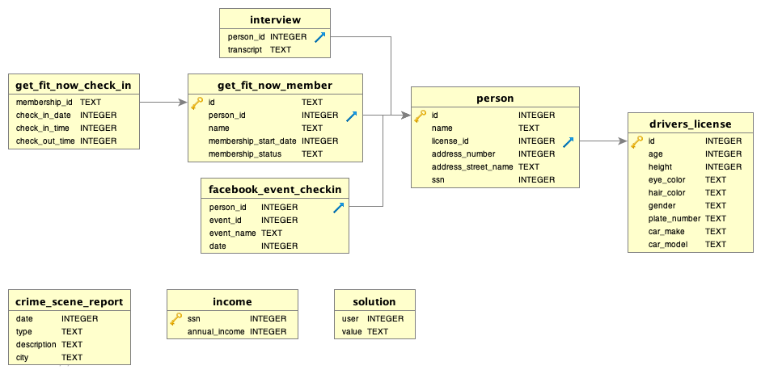

- WITNESSES

20180115 | murder | Security footage shows that there were 2 witnesses. The first witness lives at the last house on "Northwestern Dr". The second witness, named Annabel, lives somewhere on "Franklin Ave". | SQL City

Annabel Miller | Franklin Ave | 103
Morty Schapiro | Northwestern Dr | 4919

- INTERVIEW TRANSCRIPT
id | name | person_id | transcript
14887 | Morty Schapiro | 14887 | I heard a gunshot and then saw a man run out. He had a "Get Fit Now Gym" bag. The membership number on the bag started with "48Z". Only gold members have those bags. The man got into a car with a plate that included "H42W"..
16371 | Annabel Miller | 16371 | I saw the murder happen, and I recognized the killer from my gym when I was working out last week on January the 9th.

SELECT get_fit_now_member.person_id, person.id, person.name
FROM get_fit_now_member
JOIN person
ON get_fit_now_member.person_id = person.id
WHERE person.id LIKE "48Z%"

- 2 SUSPECTS

membership_id | check_in_date | check_in_time | check_out_time
48Z7A | 20180109 | 1600 | 1730
48Z55 | 20180109 | 1530 | 1700

id | name | license_id | address_number | address_street_name | ssn | id | person_id | name | membership_start_date | membership_status
67318 | Jeremy Bowers | 423327 | 530 | Washington Pl, Apt 3A | 871539279 | 48Z55 | 67318 | Jeremy Bowers | 20160101 | gold
28819 | Joe Germuska | 173289 | 111 | Fisk Rd | 138909730 | 48Z7A | 28819 | Joe Germuska | 20160305 | gold

- FIND THE MURDERER

Find the murderer!
It will take more than one query to find the killer, but you can just keep editing this box, keeping notes on your results along the way. When you think you know the answer, go to the next section.

1
SELECT person.name, drivers_license.plate_number
2
FROM person
3
JOIN drivers_license
4
ON person.license_id = drivers_license.id
5
WHERE name IN ("Jeremy Bowers", "Joe Germuska");

name | plate_number
Jeremy Bowers | 0H42W2

- BONUS

name | transcript
Jeremy Bowers | I was hired by a woman with a lot of money. I don't know her name but I know she's around 5'5" (65") or 5'7" (67"). She has red hair and she drives a Tesla Model S. I know that she attended the SQL Symphony Concert 3 times in December 2017.

Did you find the killer?

1
SELECT * FROM facebook_event_checkin
2
JOIN person
3
ON facebook_event_checkin.person_id = person.id
4
WHERE person.id IN (78881, 99716);

person_id | event_id | event_name | date | id | name | license_id | address_number | address_street_name | ssn
99716 | 1143 | SQL Symphony Concert | 20171206 | 99716 | Miranda Priestly | 202298 | 1883 | Golden Ave | 987756388
99716 | 1143 | SQL Symphony Concert | 20171212 | 99716 | Miranda Priestly | 202298 | 1883 | Golden Ave | 987756388
99716 | 1143 | SQL Symphony Concert | 20171229 | 99716 | Miranda Priestly | 202298 | 1883 | Golden Ave | 987756388

MIRANDA PRIESTLY ordered the murder !

